**How to Build the Dementia Friendly Music Player**

**Using a 3D Printed Case**

8 May 2019, <http://DementiaMusicPlayer.org>, Ross Porter [rosswesleyporter@gmail.com](mailto:rosswesleyporter@gmail.com)

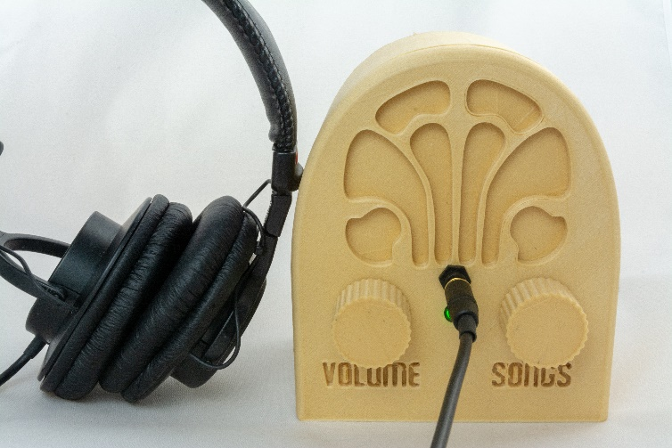  
  
My Dad could not operate normal music players. But he could operate music player like this because it operates like a familiar two-knob radio. I was inspired by the documentary [Alive Inside](http://www.aliveinside.us/#land) which shows the profound joy felt by some people with dementia when listening to their favorite music. I designed the insides and Trey Bagley designed the 3D printed case shown here.

It’s easier than you think to make one. Everything is open source. This document contains all the information you need. Good project for kids. A 13 year old can do this with minimal assistance. Younger kids with more assistance.

*3D printed case designed by Trey Bagley*



|  |  |
| --- | --- |
| **Parts cost** | ~$60 + tax + shipping |
| **Music cost** | Minimal as you should use the recipient’s existing music collection |
| **Build time** | About two hours, once you have the parts & music |
| **Parts source** | All parts can be mail ordered, links below |
| **Soldering?** | No |
| **3D printer needed?** | Yes, or work with a friend that has a 3D printer |
| **3D printing time** | About 24 hours |
| **With a friend?** | Good idea, especially if your friend has the basic tools required |
| **Beverage?** | I recommend a hoppy IPA while you are assembling |

|  |  |
| --- | --- |
|  |  |

# Preview of the build steps

|  |  |  |
| --- | --- | --- |
| **1) Order parts** | **2) 3D print pieces** | **3) Stain the pieces (optional)** |
| **4) Assemble recipient’s favorite music**  Complete Beethoven Edition, Vol. 1: Symphonies | **5) Copy software to micro SD card**  http://ecx.images-amazon.com/images/I/71sgCaQGpKL._SL1500_.jpg | **6) Collect the parts & pieces** |
| **7) Add Pi** | **8) Install front panel components** | **9) Glue it** |
| **10) Wire it** | **11) Screw on back** | **12) Enjoy!** |

# No warranty

USE THESE DQMUSICBOX PLANS AND SYSTEM AT YOUR OWN RISK. THE DQMUSICBOX PLANS ARE PROVIDED AS IS WITHOUT WARRANTY OF ANY KIND EITHER EXPRESSED OR IMPLIED, INCLUDING, BUT NOT LIMITED TO, THE IMPLIED WARRANTIES OF MERCHANTABILITY AND FITNESS FOR A PARTICULAR PURPOSE. THE ENTIRE RISK AS TO THE QUALITY AND PERFORMANCE OF THE PLANS AND SYSTEM IS WITH YOU. SHOULD THE PLANS OR SYSTEM PROVE DEFECTIVE, YOU ASSUME THE COST OF ALL NECESSARY SERVICING, REPAIR OR CORRECTION. IN NO EVENT WILL ANY PARTY BE LIABLE TO YOU FOR DAMAGES, INCLUDING ANY GENERAL, SPECIAL, INCIDENTAL OR CONSEQUENTIAL DAMAGES ARISING OUT OF THE USE OR INABILITY TO USE THE PLANS OR SYSTEM.

# Acknowledgements

People were very generous with their time, and I really enjoyed the experience. This is certainly an incomplete list: Trey Bagley, Alex & Mike & others at [Ada’s](http://blog.seattletechnicalbooks.com/), the super helpful crew at [Seattle Makers](https://seattlemakers.org/), neighbor Randy, [Stephen Christopher Phillips](http://scphillips.com/), [Bob Rathbone](http://www.bobrathbone.com/), [Stephen Rusk](http://www.stephenrusk.com/), [Graham Hill](http://www.ted.com/speakers/graham_hill), support at [Ponoko](https://www.ponoko.com/), and my son.

# What DQMusicBox does

## For the person with dementia

|  |  |
| --- | --- |
| **Name** | **Description & implementation** |
| Start song | Turning either of the knobs will start music playing. |
| Change song | Turn the songs knob. |
| Change volume | Turn the volume knob. |
| Pause | Tap the volume knob. Note that this also happens automatically – music pauses if there are no knob events in one hour. |

## For you

|  |  |
| --- | --- |
| **Name** | **Description & implementation** |
| Shut down | Pull the power plug or long hold (15-30 seconds) on the volume knob. |
| Reboot | Pull the power plug and re-insert or long hold (15-30 seconds) on the songs knob. |
| Add/remove music | By adding/removing files on the USB memory stick. |

# Order the parts

You will be ordering these parts:

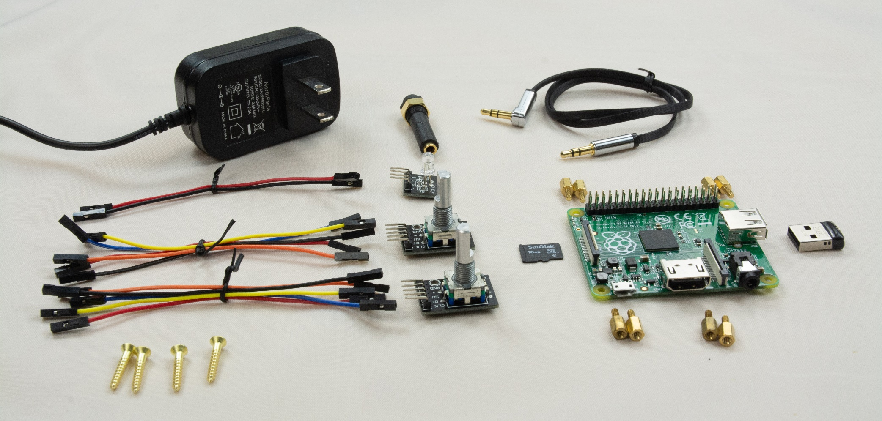

## Order the parts

|  |  |  |  |
| --- | --- | --- | --- |
| **Item** | **Supplier** | **Cost (2018)** | **Notes & Alternatives** |
| [Raspberry Pi 1 A+ single board computer](http://www.newark.com/raspberry-pi/raspbrry-moda-512m/silicon-manufacturer-broadcom/dp/81Y5333) | Newark | $18.00 | Tested with a Raspberry Pi 1A+, 2B, 3A+, 3B, 3B+. Do not use Pi Zero. |
| [Power supply](http://www.mcmelectronics.com/product/28-19338) | Newark | $5.99 | This is the US model. Any micro USB 2A or better supply will do. |
| [Female-female jumper wires](http://www.newark.com/adafruit/266/female-to-female-jumper-wires/dp/42X1200) | Newark | $3.56 | Or buy Amazon [B01L5ULRUA](https://www.amazon.com/GenBasic-Female-Solderless-Breadboard-Prototyping/dp/B01L5ULRUA/ref=sr_1_3?s=electronics&ie=UTF8&qid=1524365861&sr=1-3&keywords=female+female+jumper+wires) |
| [Panel mount 3.5mm headphone jack](http://www.newark.com/mcm/27-5937/3-5mm-inline-stereo-mount-female/dp/40T6284) | Newark | $2.69 | Or buy Amazon [B004JX64FE](https://www.amazon.com/3-5mm-Stereo-Feed-Thru-Panel-Mount/dp/B004JX64FE/ref=sr_1_1?s=electronics&ie=UTF8&qid=1508035643&sr=1-1&keywords=B004JX64FE) |
| [M2.5 standoffs (screws)](http://www.newark.com/raf-electronic-hardware/m2102-2545-al/spacer-standoff-hex-aluminium/dp/27T7975?st=M2.5%20standoff) – 8 of them | Newark | $3.84 | Or by Amazon [B06XXV8RTR](https://www.amazon.com/eBoot-Pieces-Female-Standoff-Assortment/dp/B06XXV8RTR/ref=sr_1_1?s=electronics&ie=UTF8&qid=1508035656&sr=8-1&keywords=B06XXV8RTR) |
| [Micro SD card 32GB](https://www.amazon.com/dp/B06XWN9Q99/ref=psdc_3015433011_t1_B079GTYCW4) | Amazon | $5.99 | Any brand name micro SD card that is 8GB or larger will do. |
| [USB thumb drive 16GB](https://www.amazon.com/dp/B005FYNSZA/ref=twister_B00JO6RO8C?_encoding=UTF8&th=1) | Amazon | $6.50 | While nearly any USB thumb drive will work, I recommend one that is physically tiny so it doesn't protrude much from the case. |
| [Audio cable](https://www.amazon.com/gp/product/B00LM0U8I6/ref=oh_aui_detailpage_o00_s00?ie=UTF8&psc=1) | Amazon | $5.88 | Or find a short audio cable with a right angle bend. |
| [#4 x 5/8” flat head wood screws (5 screws)](https://www.ebay.com/itm/Flat-Head-Phillips-Wood-Screw-Brass-Plated-Bag-of-25-2-3-4-5-6-by-PLD/251913149712?hash=item3aa7319d10:m:mFySFUPZWxtQ0MH2uNh80_A:sc:USPSFirstClass!98112!US!-1:rk:1:pf:0&var=550794019233) | eBay | $1.49 | Or buy at your local hardware store |
| [KY-016 indicator LED (note shipping time)](https://www.ebay.com/itm/5pcs-KY-016-RGB-3-Color-Full-Color-LED-Module-for-Arduino/400985215745?epid=1148542974&hash=item5d5c94d301:g:2RUAAOSw3EVaYbqU) | eBay | $1.62 | The linked seller ships from China, takes 2-3 weeks. Or order as one piece of this kit - Amazon [B013UL6LFS](https://www.amazon.com/SainSmart-Arduino-Mega2560-Mega328-Raspberry/dp/B013UL6LFS/ref=sr_1_2?s=electronics&ie=UTF8&qid=1519626123&sr=1-2&keywords=KY-016), which will arrive in a few days (assuming you live in the US). |
| [KY-040 rotary encoders (knobs)](https://www.ebay.com/itm/5pcs-KY-040-Rotary-Encoder-Module-for-Arduino-AVR-PIC/302391739386?epid=1386840178&hash=item4667f3c3fa:rk:1:pf:0) | eBay | $6.36 | Or buy Amazon [B074TJ8RSX](https://www.amazon.com/Cylewet-KY-040-Encoder-Arduino-CYT1077/dp/B074TJ8RSX/ref=sr_1_1_sspa?s=electronics&ie=UTF8&qid=1544335653&sr=1-1-spons&keywords=KY-040&psc=1). |
| **TOTAL** |  | **$62.12** | Prices will vary. Does not include tax, shipping. |

## About headphones

|  |  |  |
| --- | --- | --- |
| **Item** | **Cost** | **Notes and alternatives** |
| The recipient’s existing headphone | $0.00 | The best headphones are the headphones that the recipient is already used to. |
| [Monoprice On-Ear headphones](https://www.monoprice.com/product?c_id=120&cp_id=12001&cs_id=1082302&p_id=13191&seq=1&format=2) | $10.99 | Very good sound. |
| [Monoprice Over-the-Ear headphones](https://www.monoprice.com/product?c_id=120&cp_id=12001&cs_id=1082302&p_id=8323&seq=1&format=2) | $15.99 | Amazing sound. My musician son rates the sound as better than the ever-popular Sony MDR7506 headphones. |
| Other |  | Look for high sensitivity headphones, as the Pi’s output is a bit weak. |

## Tools & supplies

You probably have some of these tools & supplies. If you don’t, you have a spouse or child or friend that does. This project is exactly the sort of thing that a friend would be happy to help you with.

|  |  |
| --- | --- |
| **Link to order item** | **Notes & alternatives** |
| Elmer’s wood glue | Any wood glue will do |
| 3/16th wrench or nut driver | Or needle-nosed pliers. Or really strong fingers |
| SD card reader/writer | Your computer may have an SD card reader/writer. If not, you probably have a friend that does. Or order a [USB SD-card reader](https://www.amazon.com/gp/product/B00OJ5WBUE/ref=oh_aui_search_detailpage?ie=UTF8&psc=1) for your computer. |
| Painter’s tape | Any tape that comes off easily will do. Painter’s tape is great. Regular masking tape is probably fine too. I haven’t tried Scotch tape. |
| Light blocking tape or sticker | The unit’s LED is quite bright, so I prefer to block some of the light. You can use the tape above. Or order light blocking stickers such as [B009WSJNCW](https://www.amazon.com/LightDims-Original-Strength-Electronics-Appliances/dp/B009WSJNCW/ref=sr_1_1?s=hi&ie=UTF8&qid=1526237408&sr=1-1&keywords=B009WSJNCW). |
| PLA wood filament (optional) | This document assumes that you have a 3D printer, or you have a friend with a 3D printer. So you already have some regular PLA filament. I chose to use a PLA wood filament, specifically [Monoprice PLA wood filament](https://www.monoprice.com/product?p_id=12507). |
| Wood stain (optional) | If you print with PLA wood filament, you can optionally apply wood stain. I used a pre-stain, a stain, and a protective finish. I went to the local hardware store and purchased what they recommended: [Minwax Pre-Stain Wood Conditioner](https://www.minwax.com/wood-products/preparation/minwax-prestain-wood-conditioner), [Minwax Wood Finish Red Mahogany 225](https://www.minwax.com/wood-products/stains/minwax-wood-finish#colors), [Minwax Polycrylic Protective Finish](https://www.minwax.com/wood-products/clear-protective-finishes/interior/minwax-polycrylic-protective-finish). |
| Raspberry Pi 3 (optional) | This is in addition to the Pi that goes in the player. This is a completely optional step. If you are nerd like me, or you have nerdly friend, see details in the appendix 1. |

# 3D print pieces

The key assumption is that you have a 3D printer, or you have a friend with a 3D printer. Thus, this document is not intended as an introduction to 3D printing.

You will be printing the pieces that you see below. You should print in the orientation that you see below i.e. flat side down. On my basic 3D printer, the total print time was about 18 hours.

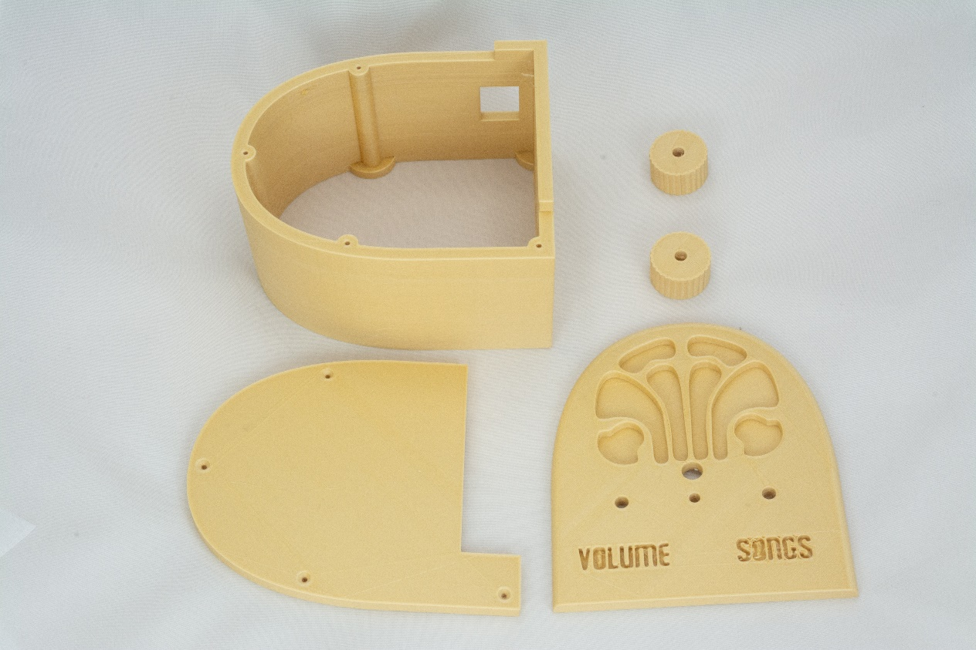  
 *3D printed case designed by Trey Bagley*

## General instructions

1. [Download the stl files from Github](https://github.com/rosswesleyporter/dqmusicbox/tree/master/case/3D_printed).
2. 3D print the files.

## My experience

Trey Bagley designed the case. I think he did a great job. But I’m a novice at 3D printing. Nonetheless here is what I did, and I’m happy with the result:

* [Monoprice Maker Select v2 3D printer](https://www.monoprice.com/product?p_id=13860)
* [Monoprice PLA wood filament](https://www.monoprice.com/product?p_id=12507)
* [Cura slicing software](https://ultimaker.com/en/products/ultimaker-cura-software)
* NOTE: For the knobs (Dials.stl), you may have to scale prior to printing. In my case, Cura (slicer) automatically scaled by 10,000% - no action required on my part. You may need to manually scale in your slicer, presumably by 10,000%. In any case, the dials should be ~30mm in diameter.
* Key settings
  + Layer height: 0.3mm
  + Initial layer height: 0.3mm
  + Wall thickness: 0.8mm
  + Top/bottom thickness: 0.8mm
  + Infill: 10%
  + Print temp: 188C (this low temperature reduced stringing issues)
  + Build plate temp: 50C
  + Diameter: 1.75mm
  + Flow: 100%
  + Enable retraction: yes
  + Retraction distance: 10mm
  + Retraction speed: 60mm/sec
  + Print speed: 45mm/sec
  + Infill speed: 50mm/sec
  + Travel speed: 120mm/sec
  + Initial layer speed: 5mm/sec
  + Enable print cooling: yes
  + Fan speed: 100%
  + Minimum layer time: 5 sec
  + Print sequence: all at once
* Post printing
  + My prints came out fairly clean, but I did use a tiny knife to extract extraneous strands from the lettering.

# Stain the pieces (optional)

This step is optional. I wanted to make something that seems familiar to someone with dementia i.e. make something that looks very much like a radio from the 1930s. These antique radios are made of wood and generally dark stained. Thus, I chose to print with a wood PLA filament and stain the print. You could choose to print with regular PLA filament. Or print with wood PLA but not stain it.

Here is the before and after of staining the front face:

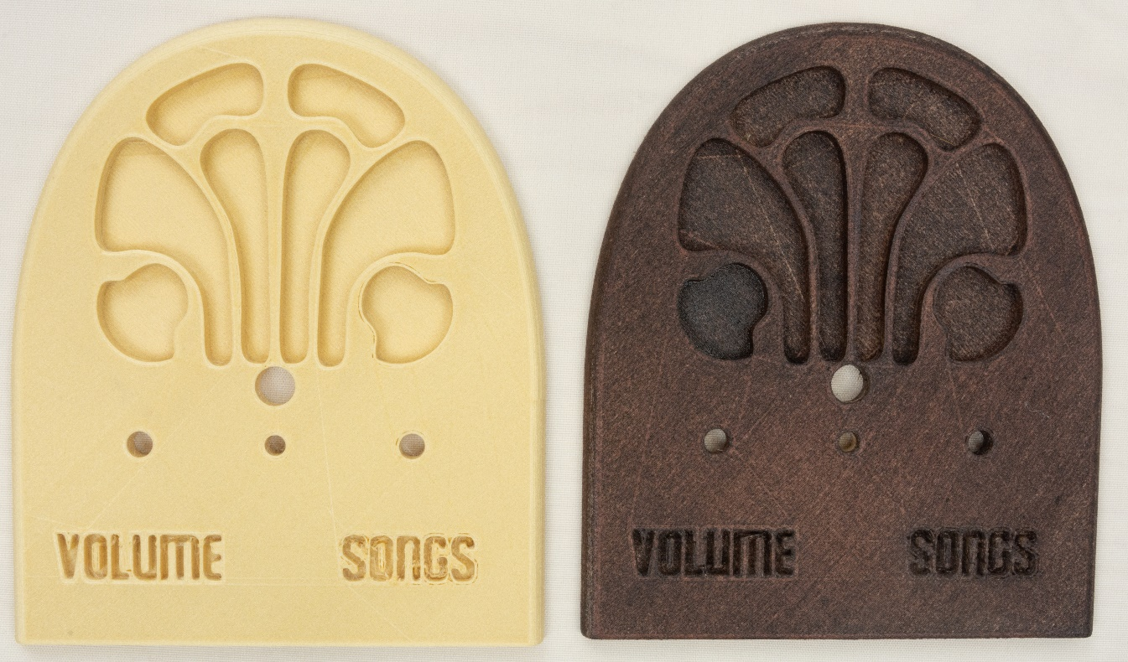

I’m not a woodworker. Nonetheless, this is the process that I used:

1. Sand the parts with a fine grit sandpaper.
2. Apply [Minwax Pre-Stain Wood Conditioner](https://www.minwax.com/wood-products/preparation/minwax-prestain-wood-conditioner), let dry. Or a similar product. Minwax is what my neighborhood hardware store has…
3. Apply [Minwax Wood Finish, Red Mahogany 225](https://www.minwax.com/wood-products/stains/minwax-wood-finish#colors). I applied a thin even coat. Minwax suggests waiting 15 minutes then wiping off the excess stain. I found this removed too much of the stain. So I didn’t do any wiping off and just let it dry overnight.
4. Apply [Minwax Polycrylic Protective Finish](https://www.minwax.com/wood-products/clear-protective-finishes/interior/minwax-polycrylic-protective-finish), let dry.

# Assemble the personalized collection of music

## Choosing the music – go for familiar favorites

This is the most important step. The personalized (familiar) music is the fundamental magic. You don’t need much music, perhaps 6-10 albums. But only familiar favorites. In my case, my Mom mailed me my Dad’s favorite CDs. It will take two weeks for the parts above to arrive, so you have time to do this well. Though it is easy to change the set of music later.

## Put the music on the USB memory stick

Organize the digitized music into folders on the USB memory stick, one folder per album. MP3, iTunes, and FLAC files are supported i.e. files with extensions .mp3, .m4a, .flac. In the end, you should have a set of folders that looks something like this:



# Prepare the micro-SD memory card

I prepared a disk image for you. It has all the required software. Your job is to download this disk image and then write it to the micro-SD card. The steps:

1. Install [Etcher](https://etcher.io/) on your PC or Mac or Linux computer. [Win32 Disk Imager](http://sourceforge.net/projects/win32diskimager/) also works.
2. Download the [Dementia Friendly Music Player disk image](http://bit.ly/2EHcJDa).  
   
3. Confirm download – “Download anyway”  
   
4. Put the micro-SD memory card into the SD card adapter that it came with i.e. put the tiny card into the larger card.
5. Put the SD card adapter into the SD reader/writer in your computer.
6. Start Etcher, instruct it to write the image file to the SD card:  
   
7. Wait for the writing to complete, ~10 minutes. This would be a good time to make a sandwich.

# Collect the parts and pieces

You should now have the following:

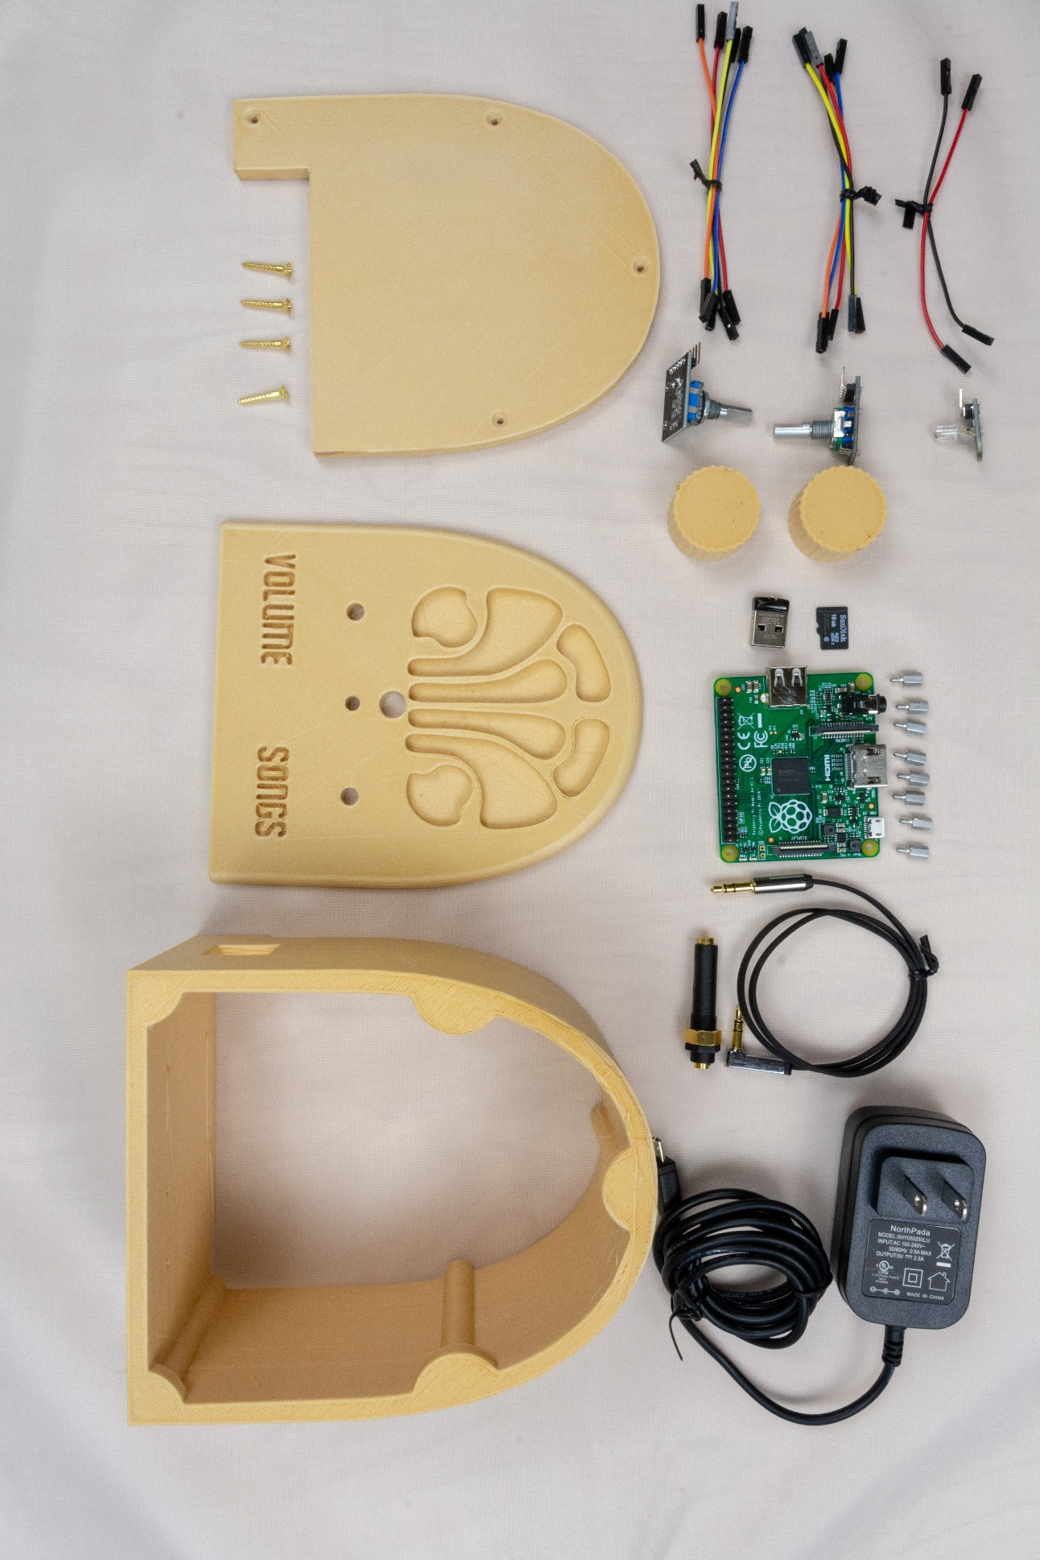

# Add Pi

## Put the MicroSD card and the USB drive into the Pi

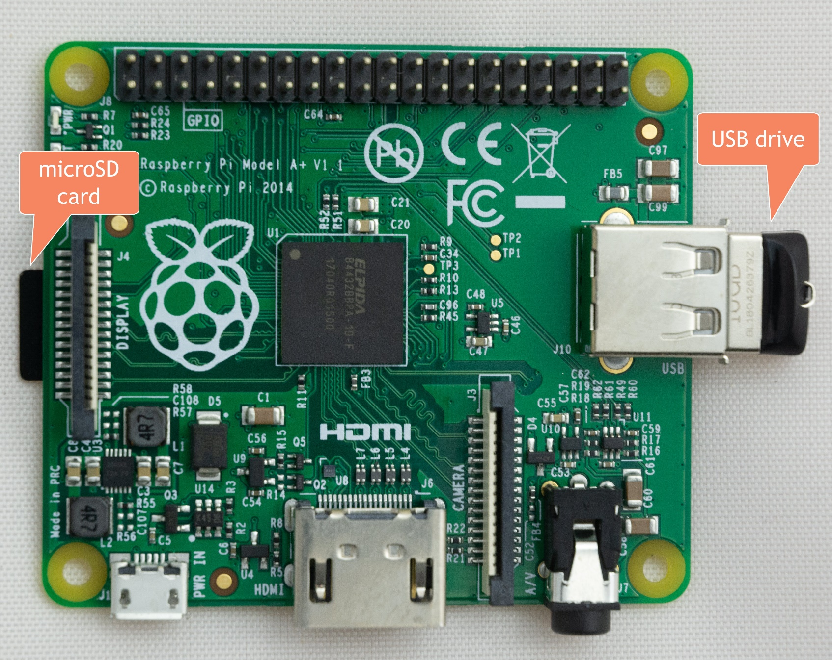

## Mount the Pi

Using the standoffs, mount the Pi in the body piece:

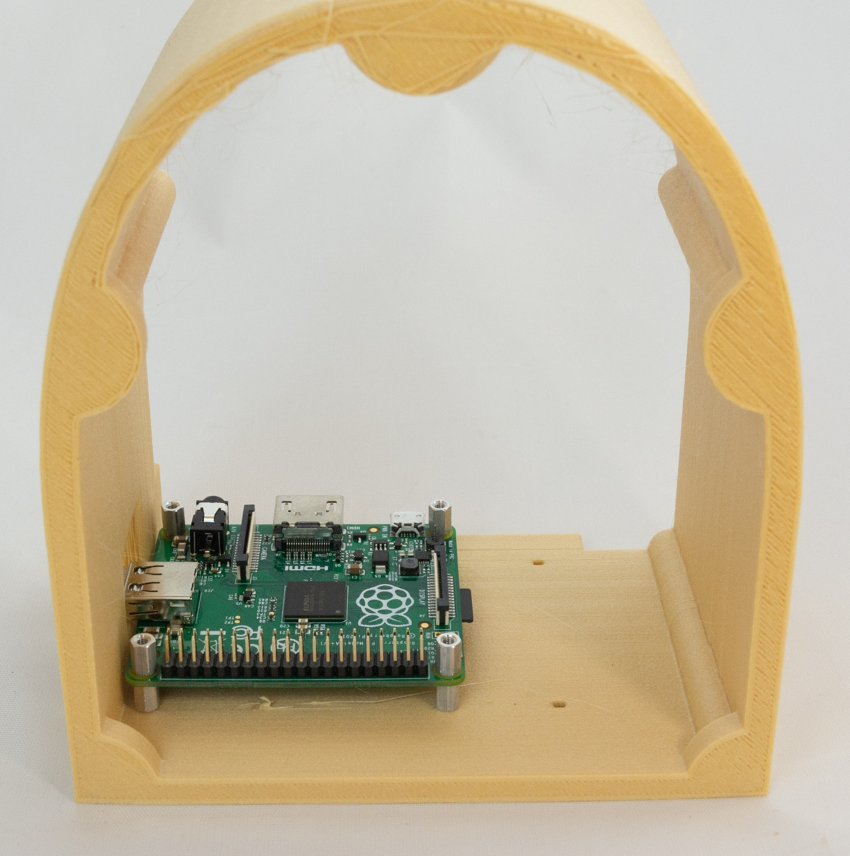

# Install front panel components

Install the two rotary encoders (knobs), the LED, and the headphone jack. The rotary encoders need to be screwed in as far as they will go, or the button press won’t work – test the rotary encoders to make sure they rebound from a button press.

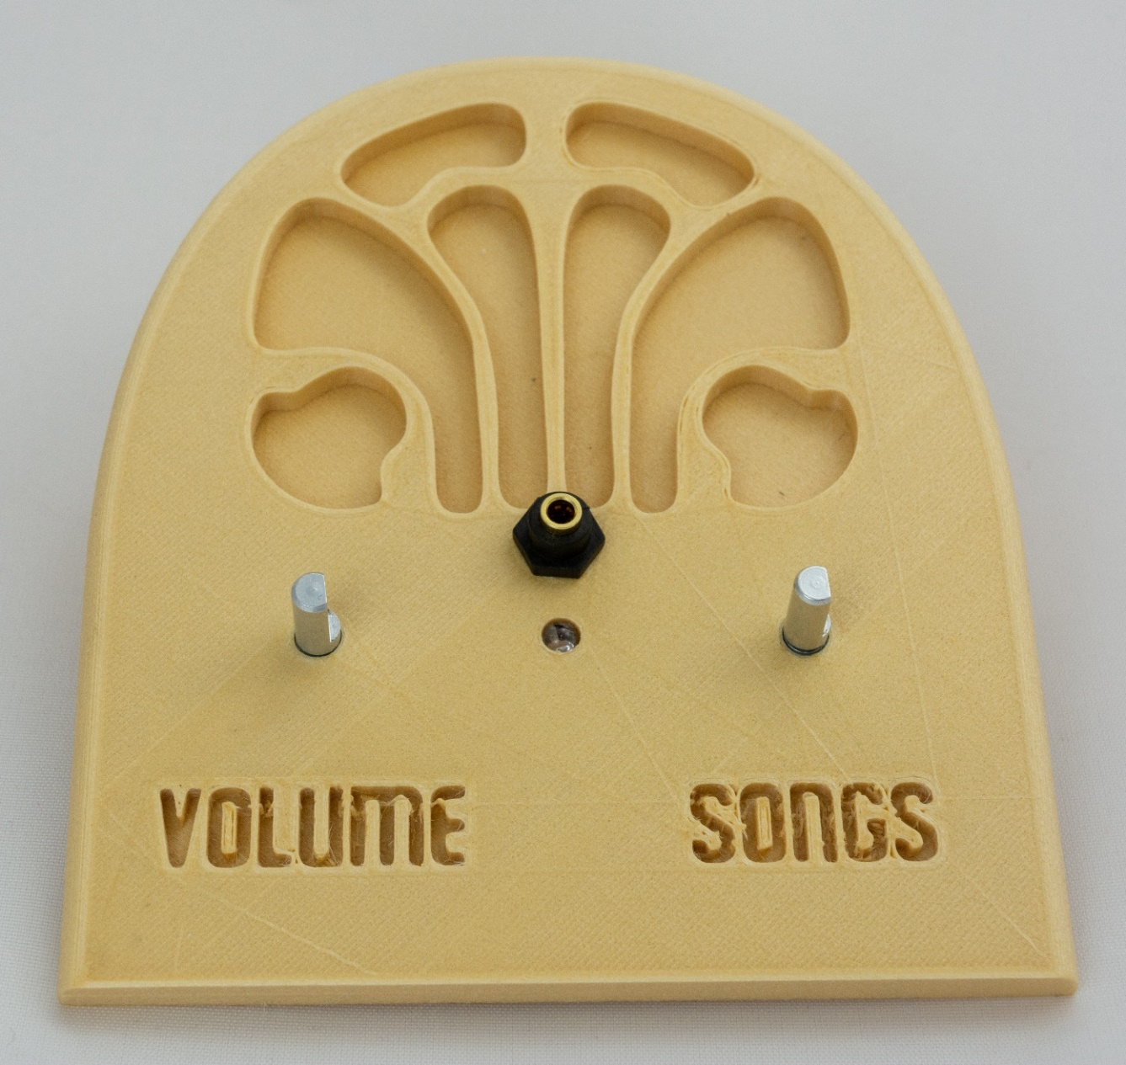

# Apply glue

Apply glue to the front of the body piece:

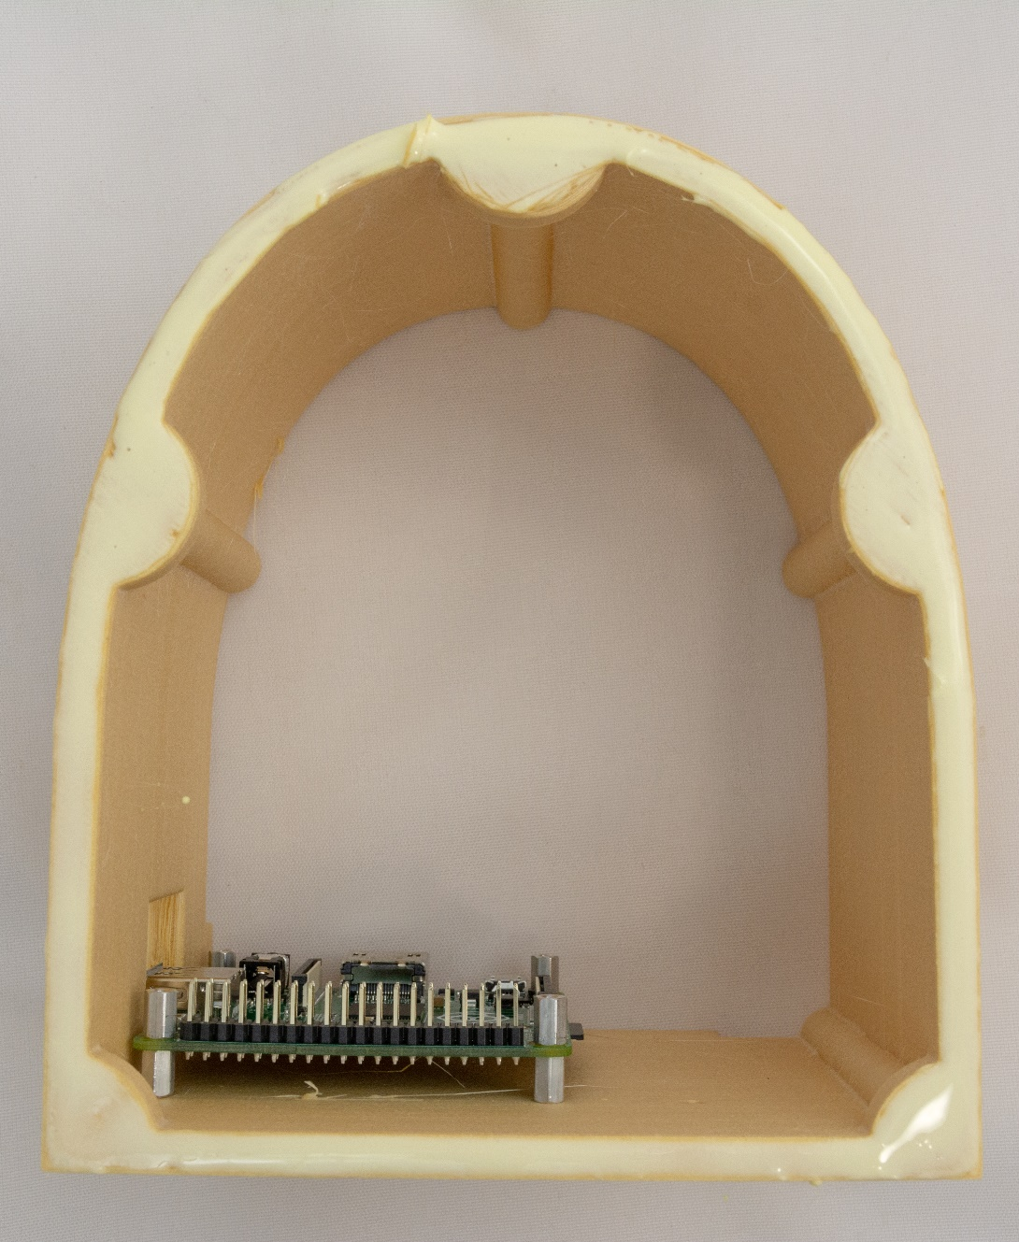

# Glue on the face

Glue on the face, using painter’s tape to clamp:

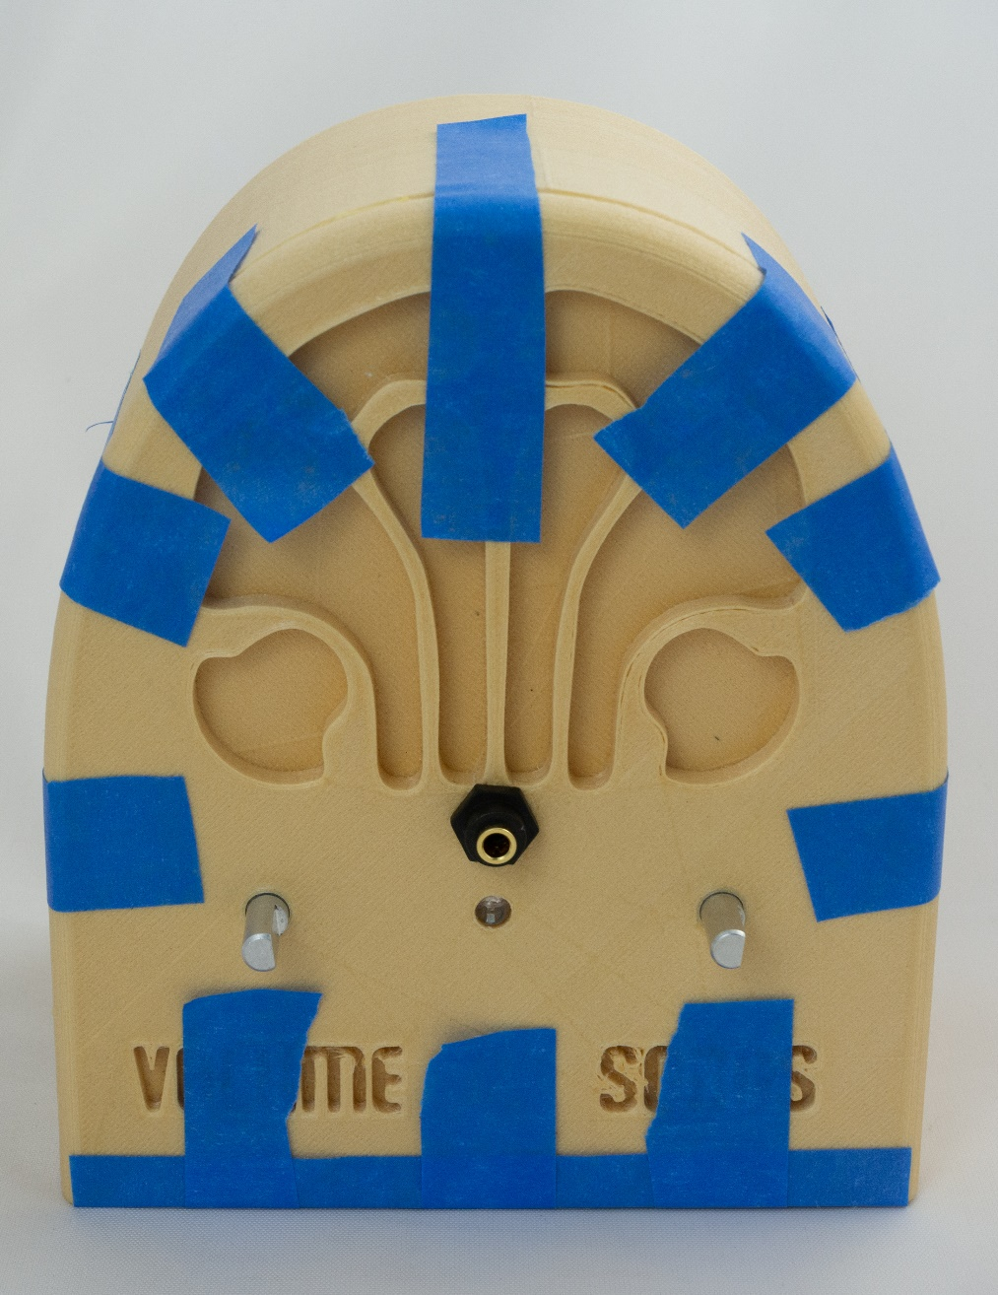

# Wire it

## Wire the knobs & LED

Attach wires from the knobs and the LED to the Raspberry Pi as per the diagram and photos below. No soldering required – just press the wires into place. **This is where most build errors happen, so please carefully check your work.**



The result should be as you see it below. The front of the LED should be flush with the front of the face. If the LED is a bit loose, just use some glue.

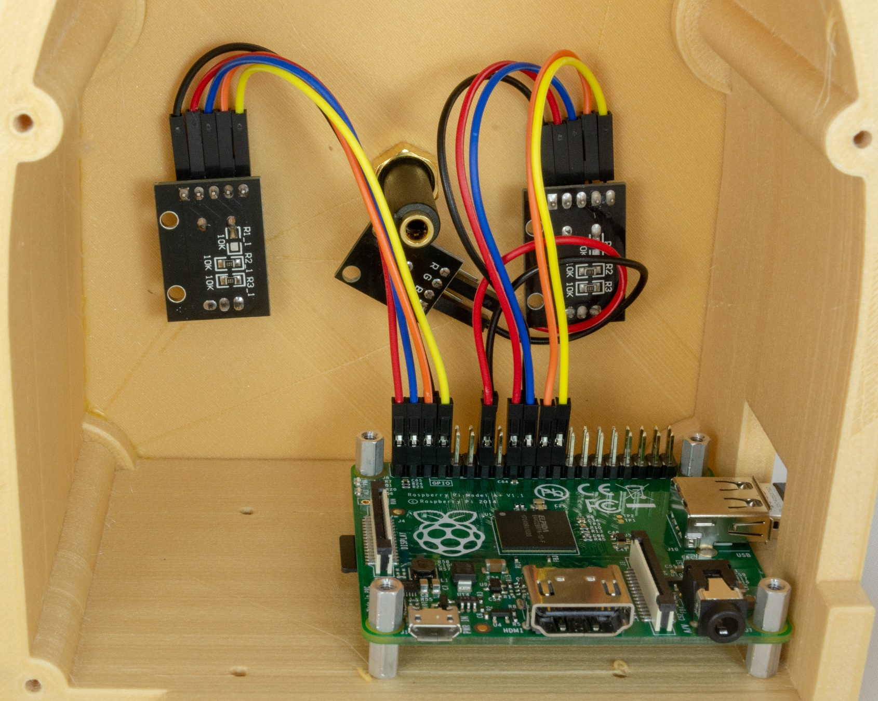

## Add the audio cable

The audio cable goes from the back of the Pi to back of the front panel’s headphone jack:

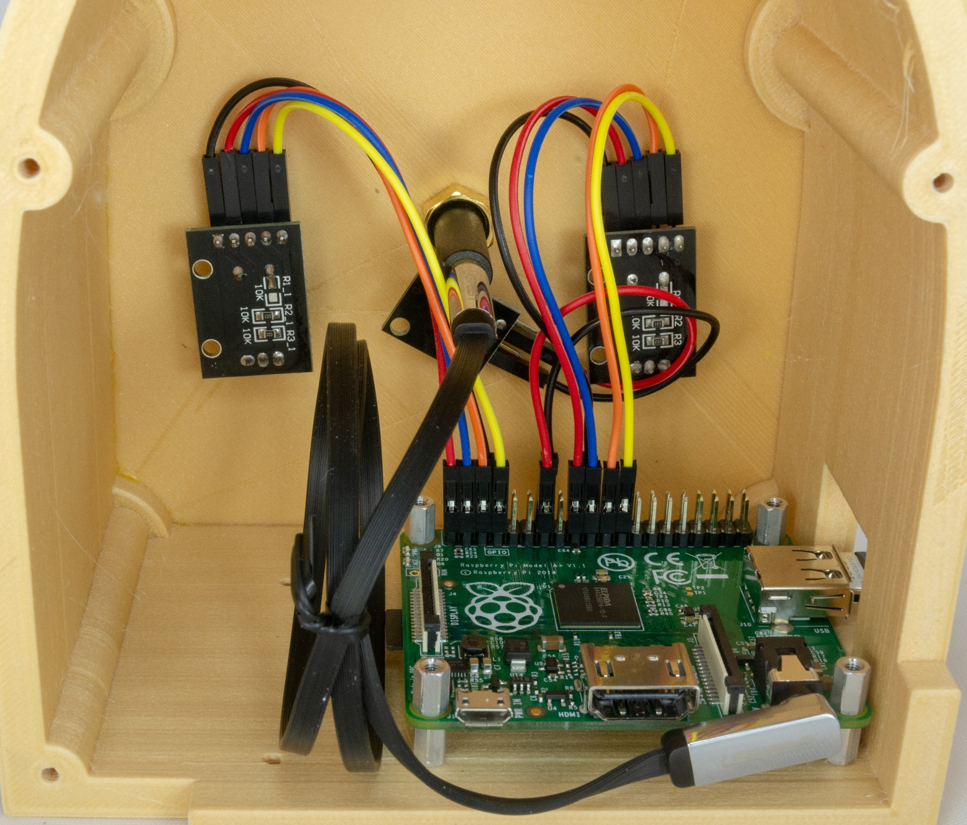

# Screw on the back

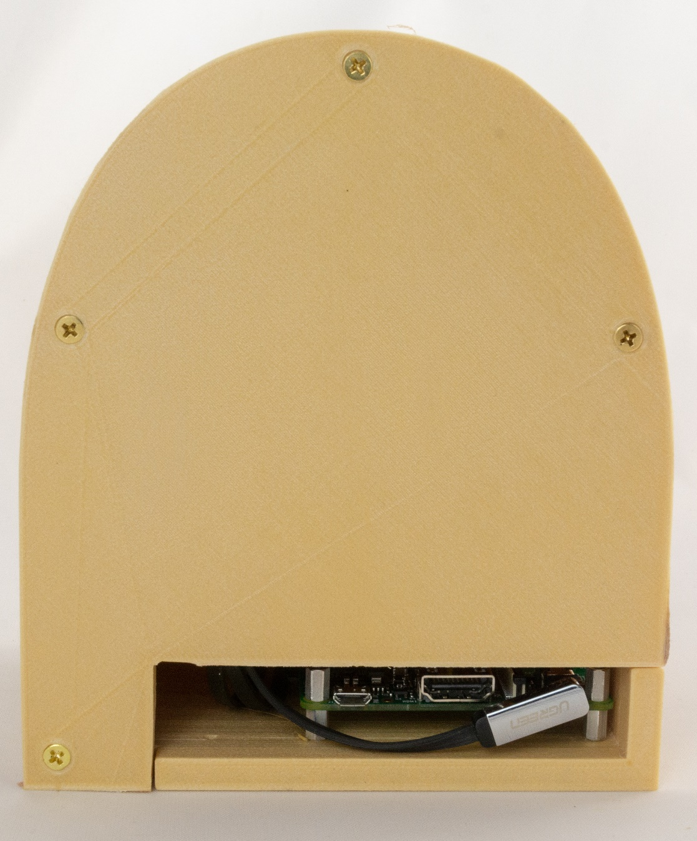

# Put the knobs on and enjoy!

If the knobs don’t easily slide on the metal shafts, just heat the knobs up with a heat gun or hair dryer or (last resort) boiling water. You can also put some grease or cooking oil on the metal shafts.

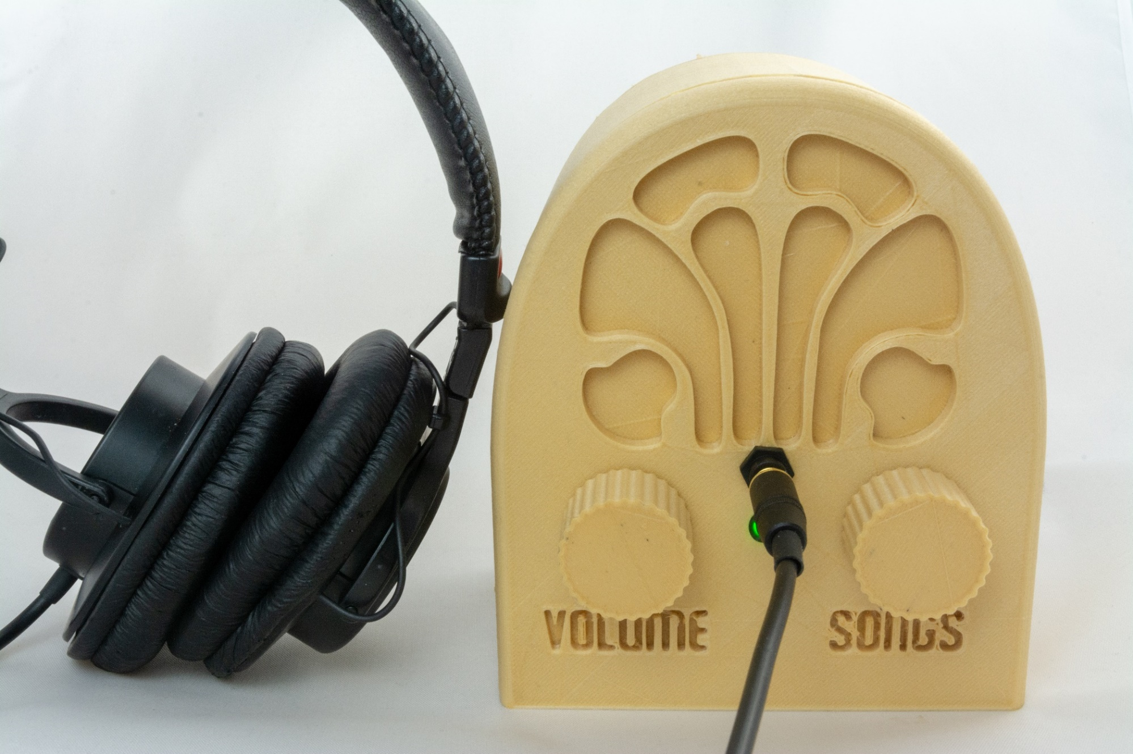

## Test it

Now that you have assembled everything, it is time to test.

|  |  |
| --- | --- |
| **Test** | **Description & Expectation** |
| Light 20sec after power on | The indicator LED turns on when DQMusicBox is ready to play music, which is generally about 15 seconds after power on. |
| Start song | Turning either of the knobs will start music playing. |
| Change song | Turn the songs knob. If you go forward and backward through the song list as expected, then all is well. |
| Change volume | Turn the volume knob. If the volume goes up and down as expected, then all is well. |
| Pause | Tap the volume knob, song should pause. Tap the songs knob, this should also pause the song. |
| Unpause | Tap a knob |

## If one or both knows do the opposite of what you expect

Once assembled, you may find your knobs doing the opposite of what you expect e.g. a clockwise turn decreases the volume. This is because there are two kinds of rotary encoders out there. Happy, the fix is easy, just switch the orange and yellow wires on the misbehaving knob(s) (don’t touch the Pi itself):

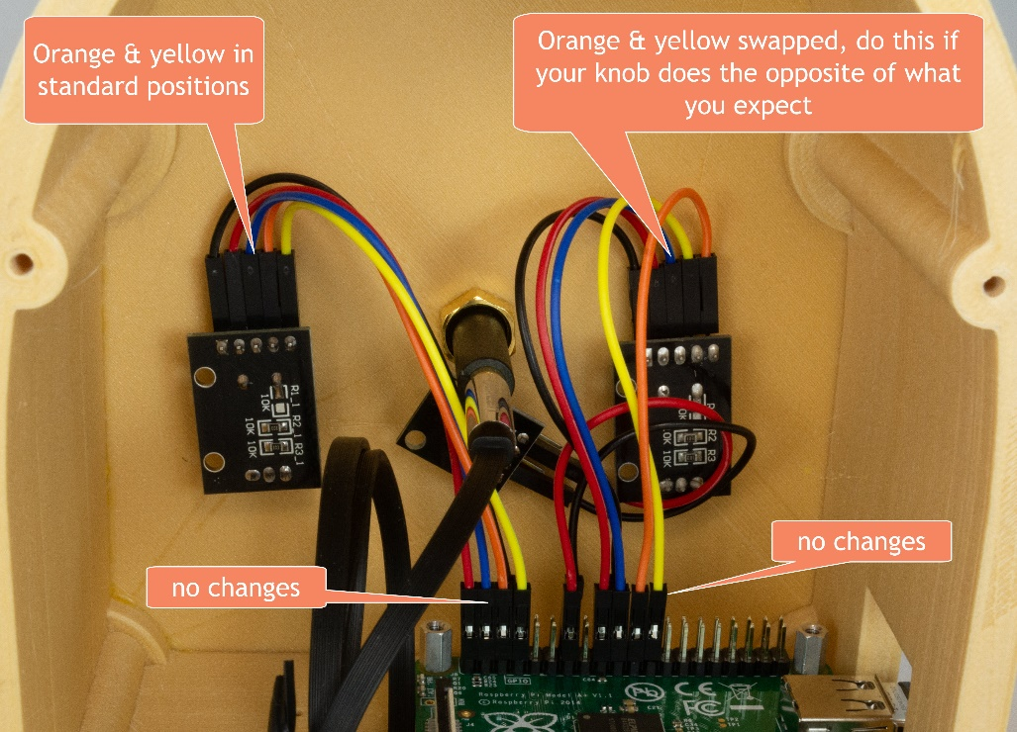

## Tape instructions

Print this page and tape the instructions in the box below to the bottom of your new DQMusicBox:

|  |
| --- |
| **To create personalized music**  **Organize the music on your computer**  One folder per album. Use MP3 files, must have .mp3 file extension. Or iTunes files (.m4a). Or FLAC files (.flac). Optionally, use folder names prefixes to specify the play order e.g. A_, B_  **Copy the music to the USB thumb drive**   1. https://images-na.ssl-images-amazon.com/images/I/71cTRglrgcL._SL1500_.jpgUnplug your DQMusicBox. 2. Remove the USB thumb drive and place in your computer. 3. Copy music files from your computer to the USB thumb drive. 4. Put the USB thumb drive back in the DQMusicBox. 5. Plug in your DQMusicBox. |

## Congratulations

Congratulations! You should have a fully functional DQMusicBox.

## Let me know how it went

I’d love to hear how your build process went and if it was useful for the recipient. [rosswesleyporter@gmail.com](mailto:rosswesleyporter@gmail.com)

# Appendix 1: Change log

|  |  |
| --- | --- |
| v1, November 2015 | Original release |
| v2, September 2016 | * Changed music storage from a micro-SD memory card to a conventional USB memory stick. * Changed the base Operating System from full Raspbian to [DietPi](http://dietpi.com/) – much smaller, so faster to boot, and less to go wrong. |
| v3, January 2017 | * Changed from USB audio to Pi built-in audio, including a firmware update for excellent audio quality. |
| v4, May 2017 | * Switched to bamboo for durability and use of standoffs. * Switched to Pi A+ to lower cost. * Made USB thumb drive externally accessible, to make it easier for the caregiver to organize music. |
| v4.01, 25 June 2017 | * Minor edits. |
| v4.01_1, 20 July 2017 | * Minor edits. |
| v4.01_2, 11 August 2017 | * Added links for ordering parts in the UK. * Added detailed instructions for write protecting a micro-SD card. |
| v4.01_3, 12 August 2017 | * Minor edits |
| v4.01_4, 12 August 2017 | * Minor edits |
| v4.01_5, 14 October 2017 | * Edited text and updated photographs to reflect the change from an HDD-style LED to a KY-016 LED module. |
| v4.01_6, 26 February 2018 | * Updated the links for purchasing the parts. No changes to the parts themselves, just the links. * Minor change to the instructions, noting how the build can be accomplished in one sitting, if desired. |
| v4.1, 7 April 2018 | * Reflects that the software has been updated to support the new Raspberry Pi 3 B+. No new software features. |
| v4.1_1, 23 April 2018 | * Updated to reflect the new bamboo case design. |
| V4.1_1, 6 May 2018 | * Adapted the existing instructions to match the new 3D printed case design. |
| 27 January 2019 | * Noted support for the Raspberry Pi 3A+. |
| v4.2, 1 March 2019 | * Switched to pmount for USB drive auto mounting. |
| v4.2, 7 April 2019 | * Removed instructions for write protecting the SD card – rarely used and may cause certain rare problems |
| v4.2, 8 May 2019 | * Noted that it may be necessary to do in-slicer scaling of one the STL files prior to 3D printing. |